Major Spherical Cap
# Source: AI Source: Provided by: [Data Path: Persons Table -> ID Column: 1, Name_En Column: Motasem Essam] -> From: [ChatGPT] on [7/25/2026]
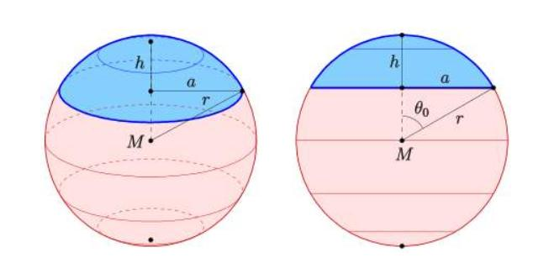

Definition
# Source: AI Source: Provided by: [Data Path: Persons Table -> ID Column: 1, Name_En Column: Motasem Essam] -> From: [ChatGPT] on [7/25/2026]
A major spherical cap is the larger portion of a solid sphere separated by a plane that does not pass through the sphere's center, where the cap extends from the cutting plane toward the sphere's farther pole.
It has a circular base and a curved spherical surface. Its height $h$, measured perpendicular to the base plane from the plane to the farthest point of the cap, is greater than the sphere's radius.
For a sphere of radius $R$:
$$R<h<2R$$
The major spherical cap is the larger cap formed by a plane that cuts the sphere away from its center.

Simple Definition
# Source: AI Source: Provided by: [Data Path: Persons Table -> ID Column: 1, Name_En Column: Motasem Essam] -> From: [ChatGPT] on [7/25/2026]
A major spherical cap is the larger part of a sphere cut off by a plane, with cap height greater than the sphere's radius.

Geometric Elements
# Source: AI Source: Provided by: [Data Path: Persons Table -> ID Column: 1, Name_En Column: Motasem Essam] -> From: [ChatGPT] on [7/25/2026]
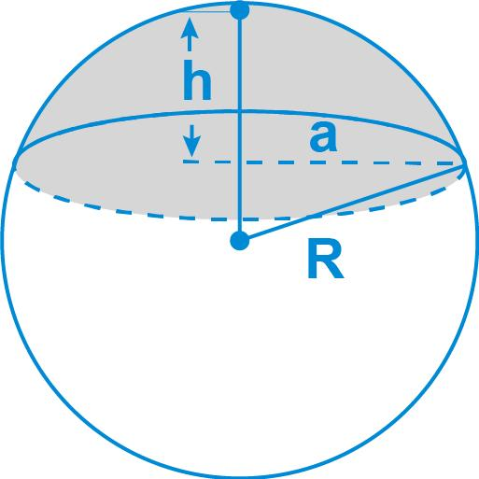
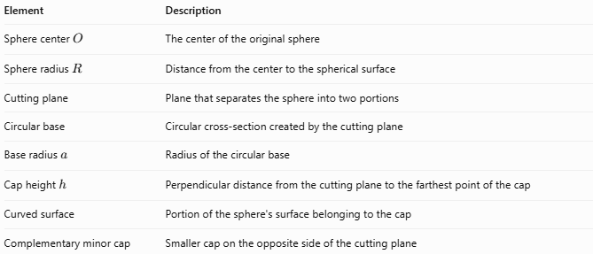
Element | Description
Sphere center $O$ | The center of the original sphere
Sphere radius $R$ | Distance from the center to the spherical surface
Cutting plane | Plane that separates the sphere into two portions
Circular base | Circular cross-section created by the cutting plane
Base radius $a$ | Radius of the circular base
Cap height $h$ | Perpendicular distance from the cutting plane to the farthest point of the cap
Curved surface | Portion of the sphere's surface belonging to the cap
Complementary minor cap | Smaller cap on the opposite side of the cutting plane
Important: The major cap includes more than half of the sphere's volume. Its base circle is smaller than a great circle because the cutting plane does not pass through the center.

Mathematical Properties and Formulas
# Source: AI Source: Provided by: [Data Path: Persons Table -> ID Column: 1, Name_En Column: Motasem Essam] -> From: [ChatGPT] on [7/25/2026]
Let:
- $R$ = sphere radius
- $h$ = major cap height
- $a$ = radius of the circular base
- $V$ = cap volume
- $A_{c}$ = curved surface area
- $A_{t}$ = total surface area, including the flat base

Height
# Source: AI Source: Provided by: [Data Path: Persons Table -> ID Column: 1, Name_En Column: Motasem Essam] -> From: [ChatGPT] on [7/25/2026]
$$R<h<2R$$
The cap height is greater than the sphere radius but less than the sphere's diameter.

Base Radius
# Source: AI Source: Provided by: [Data Path: Persons Table -> ID Column: 1, Name_En Column: Motasem Essam] -> From: [ChatGPT] on [7/25/2026]
$$a=\sqrt{2Rh-h^{2}}$$
Equivalently,
$$a=\sqrt{R^{2}-{\left(h-R\right)}^{2}}$$

Volume
# Source: AI Source: Provided by: [Data Path: Persons Table -> ID Column: 1, Name_En Column: Motasem Essam] -> From: [ChatGPT] on [7/25/2026]
$$V=\frac{πh^{2}}{3}\left(3R-h\right)$$
This formula gives the volume of the major cap directly when $h$ is its full height.

Curved Surface Area
# Source: AI Source: Provided by: [Data Path: Persons Table -> ID Column: 1, Name_En Column: Motasem Essam] -> From: [ChatGPT] on [7/25/2026]
$$A_{c}=2πRh$$

Total Surface Area
# Source: AI Source: Provided by: [Data Path: Persons Table -> ID Column: 1, Name_En Column: Motasem Essam] -> From: [ChatGPT] on [7/25/2026]
Including the circular base:
$$A_{t}=2πRh+πa^{2}$$
Substituting $a^{2}=2Rh-h^{2}$:
$$A_{t}=π\left(4Rh-h^{2}\right)$$

Worked Example
# Source: AI Source: Provided by: [Data Path: Persons Table -> ID Column: 1, Name_En Column: Motasem Essam] -> From: [ChatGPT] on [7/25/2026]
A sphere has radius $R=6\text{ cm}$. A plane cuts it to create a major spherical cap with height $h=9\text{ cm}$. Find the base radius, volume, curved surface area, and total surface area.
Given
$$R=6\text{ cm}, h=9\text{ cm}$$
Step 1 — Check the cap type
$$6<9<12$$
Therefore, it is a major spherical cap.
Step 2 — Calculate the base radius
$$\begin{aligned}a&=\sqrt{2Rh-h^{2}} \\ &=\sqrt{2\left(6\right)\left(9\right)-9^{2}} \\ &=\sqrt{27}=3\sqrt{3}\end{aligned}$$
So, $a≈5.20\text{ cm}$.
Step 3 — Calculate the volume
$$\begin{aligned}V&=\frac{πh^{2}}{3}\left(3R-h\right) \\ &=\frac{π\left(9^{2}\right)}{3}\left(18-9\right) \\ &=243π\end{aligned}$$
$$\boxed{V≈763.41{\text{ cm}}^{3}}$$
Step 4 — Calculate the curved surface area
$$A_{c}=2π\left(6\right)\left(9\right)=108π$$
$$\boxed{A_{c}≈339.29{\text{ cm}}^{2}}$$
Step 5 — Calculate the total surface area
$$\begin{aligned}A_{t}&=2πRh+πa^{2} \\ &=108π+27π \\ &=135π\end{aligned}$$
$$\boxed{A_{t}≈424.12{\text{ cm}}^{2}}$$

Comparison with Other Spherical Caps
# Source: AI Source: Provided by: [Data Path: Persons Table -> ID Column: 1, Name_En Column: Motasem Essam] -> From: [ChatGPT] on [7/25/2026]
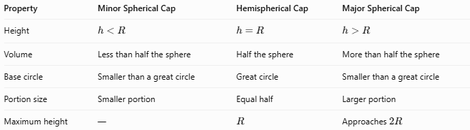
Property | Minor Spherical Cap | Hemispherical Cap | Major Spherical Cap
Height | $$h<R$$ | $$h=R$$ | $$h>R$$
Volume | Less than half the sphere | Half the sphere | More than half the sphere
Base circle | Smaller than a great circle | Great circle | Smaller than a great circle
Portion size | Smaller portion | Equal half | Larger portion
Maximum height | — | $$R$$ | Approaches $2R$

Applications
# Source: AI Source: Provided by: [Data Path: Persons Table -> ID Column: 1, Name_En Column: Motasem Essam] -> From: [ChatGPT] on [7/25/2026]
- Architecture: Understanding spherical domes and large curved shell sections.
- Engineering: Modeling portions of spherical tanks, vessels, and spherical components.
- Manufacturing: Calculating material volume and curved surface area for spherical parts.
- Mathematics: Studying sphere-plane intersections, solid volumes, and surface areas.
- Computer graphics: Representing and rendering spherical sections.

Key Points
# Source: AI Source: Provided by: [Data Path: Persons Table -> ID Column: 1, Name_En Column: Motasem Essam] -> From: [ChatGPT] on [7/25/2026]
- A major spherical cap is the larger cap formed by an off-center plane cut.
- Its height satisfies $R<h<2R$.
- Its volume exceeds half the volume of the original sphere.
- The base is a circle, not a great circle.
- The curved surface area is $2πRh$.
- Total surface area includes both the curved surface and the circular base.
- As $h$ approaches $2R$, the cap approaches the entire sphere and its base radius approaches zero.

Conclusion
# Source: AI Source: Provided by: [Data Path: Persons Table -> ID Column: 1, Name_En Column: Motasem Essam] -> From: [ChatGPT] on [7/25/2026]
A Major Spherical Cap is the larger portion of a sphere separated by a plane that does not pass through its center. Its defining property is that its height is greater than the sphere's radius, so it contains more than half of the sphere's volume. The formulas for its base radius, volume, and surface area allow it to be analyzed and applied in geometry, engineering, and design.

